Batch: D2 Roll No.: 16010221038

Name: Eshan Kalp Trivedi

Experiment / assignment / tutorial No. : 1
Grade: AA / AB / BB / BC / CC / CD /DD
Signature of the Staff In-charge with date

PCB Workshop (2021-2022)

Design and Manufacturing of Printed circuit Board (PCB).

Post Lab Subjective/Objective type Questions.

- Describe the function of double sided UV Exposure unit.

A double-sided UV Vacuum exposure unit is an essential tool for the production of parts such as double-sided PCBs. The vacuum makes these UV exposure units suitable for processing UV sensitive flexible substrate materials.

- List the software’s used for PCB layout design and explain how to design layout using DIPTRACE or EAGLE software.

There are many circuit design softwares available to satisfy diversified layout requirement, including free PCB design software, online free PCB design softwares, and industrial PCB softwares. This is the PCB design software list:

- PROTEL
- PADS
- ORCAD
- WG
- ALLEGRO
- EAGLE
- KICAD
- EASYEDA
- FRITZING

1.After downloading and installing the Eagle CAD (you might need to register with Autodesk), open the Eagle Software from the desktop shortcut. You will get the control Panel of the Eagle.

2.Click on File and select New Project. Rename the Project to an appropriate name. Right click on the project and create new schematic.

3.A new schematic window will open with a blank work space. This is called the Schematic Editor, where you can draw schematics of your design. Save the schematic file with extension .sch.

4.After this, we have to add the necessary components which we are going to use in our schematic. But, before that, we need to adjust the grid size of the schematic. Select the Grid option and set the size to 1mm. Also set the alternate grid to a smaller value. You can turn on the grid by selecting display on option.

5.Now, we have to add components to our schematic. For this, select Add Option from the side tool bar. A new window opens with a list of all the components available in the libraries.

6Click on the sheet once to place the component and if you want to rotate the component, right click. After placing the component on the schematic, press Esc to return to the component selection window
7.After placing all the components, rename the components to something understandable.

8.Next step is to connect these components. You have to use the net option from the side tool bar and start making the connections.

9.After completing the schematic, we have to proceed with the design of the PCB layout. Select the switch to board option from the top tool bar. You can create the board fie from the schematic.

10.A new window opens which is the PCB layout editor. The black space is the board area and all the components are at the outside bottom left of the board area. Now, we need to place the components in to the editor. You can adjust the grid size of the PCB Layout editor, if you want.

11.Now, using the group option from the side tool bar, select all the components and using move option move all the components and populate the board area.

12.Using the move option, place the components on the board as per the position you want the component to be on the board. You can see thin yellow wires running between the components. These wires are called air wires and are representation of connections between components.

When we route the path between components, these air wires will disappear as an indication of successful connection.

13.Now, it is time to make the connections or traces for the Printed Circuit Board. For this, we are going to use the Route tool from the side tool bar. Also set the width of the trace to be routed as your requirement.
14.Start routing the traces from pin to pin. As you progress with routing, the air wires will start disappearing. Complete all the connections and make sure that one trace do not interact with other.

- Write and explain in short the steps for fabrication of PCB.

PCB fabrication is the process or procedure that transforms a circuit board design into a physical structure based upon the specifications provided in the design package. This physical manifestation is achieved through the following actions or techniques:
•Imaging desired layout on copper clad laminates

•Etching or removing excess copper from inner layers to reveal traces and pads

•Creating the PCB layer stack up by laminating (heating and pressing) board materials at high temperatures

•Drilling holes for mounting holes, through hole pins and vias

•Etching or removing excess copper from the surface layer(s) to reveal traces and pads

•Plating pin holes and via holes

•Adding protective coating to surface or solder masking

•Silkscreen printing reference and polarity indicators, logos or other markings on the surface

•Optionally, a finish may be added to copper areas of surface

- Explain PCB in details.

A process control block (PCB) is a data structure used by computer operating systems to store all the information about a process. It is also known as a process descriptor. When a process is created (initialized or installed), the operating system creates a corresponding process control block. This specifies the process state i.e. new, ready, running, waiting or terminated.

The role of the PCBs is central in process management:

They are accessed and/or modified by most utilities, particularly those involved with scheduling and resource management.

In multitasking operating systems, the PCB stores data needed for correct and efficient process management. Though the details of these structures are system-dependent, common elements fall in three main categories:

- Process identification
- Process state
- Process control
- Status tables exist for each relevant entity, like describing memory, I/O devices, files and processes.

Memory tables, for example, contain information about the allocation of main and secondary (virtual) memory for each process, authorization attributes for accessing memory areas shared among different processes, etc. I/O tables may have entries stating the availability of a device or its assignment to a process, the status of I/O operations, the location of memory buffers used for them, etc.

Process identification data include a unique identifier for the process (almost invariably an integer) and, in a multiuser-multitasking system, data such as the identifier of the parent process, user identifier, user group identifier, etc. The process id is particularly relevant since it is often used to cross-reference the tables defined above, e.g. showing which process is using which I/O devices, or memory areas.

Process state data define the status of a process when it is suspended, allowing the OS to restart it later. This always includes the content of general-purpose CPU registers, the CPU process status word, stack and frame pointers, etc. During context switch, the running process is stopped and another process runs. The kernel must stop the execution of the running process, copy out the values in hardware registers to its PCB, and update the hardware registers with the values from the PCB of the new process.

Process control information is used by the OS to manage the process itself. This includes:

- Process scheduling state–The state of the process in terms of "ready", "suspended", etc., and other scheduling information as well, such as priority value, the amount of time elapsed since the process gained control of the CPU or since it was suspended. Also, in case of a suspended process, event identification data must be recorded for the event the process is waiting for.

- Process structuring information–the process's children id's, or the id's of other processes related to the current one in some functional way, which may be represented as a queue, a ring or other data structures

- Interprocess communication information–flags, signals and messages associated with the communication among independent processes

- Process Privileges–allowed/disallowed access to system resources

- Process State–new, ready, running, waiting, dead

- Process Number (PID)–unique identification number for each process (also known as Process ID)

- Program Counter (PC)–A pointer to the address of the next instruction to be executed for this process

- CPU Registers–Register set where process needs to be stored for execution for running state

- CPU Scheduling Information–information scheduling CPU time

- Memory Management Information–page table, memory limits, segment table

- Accounting Information–amount of CPU used for process execution, time limits, execution ID etc
.
- I/O Status Information–list of I/O devices allocated to the process.

- Draw any one electronic schematic diagram with its PCB Layout.

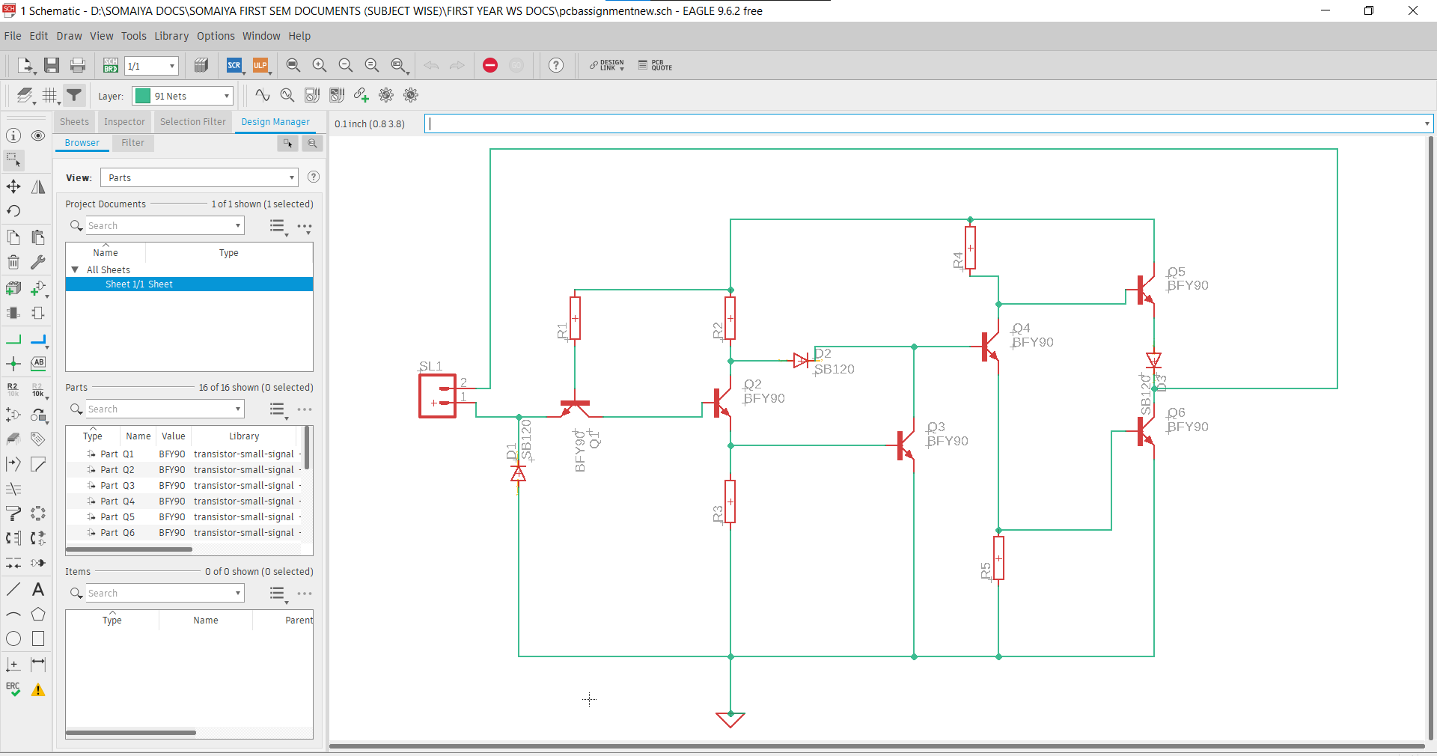

Schematic :

